EXHIBITOR & SPONSOR CONTRACT 2023
GENERAL INFORMATION
Company Name:
Company as it should appear in the program:
Name of primary contact person:
Position of primary contact person:
Address:

City:
State/Province: Postal Code:
Country:
Phone: +
Email:
Website:
On location contact person (If different):
On location contact email (If different):

PRIVATE ROOMS
SECOND LEVEL EXHIBIT DISPLAY & FEE INFORMATION

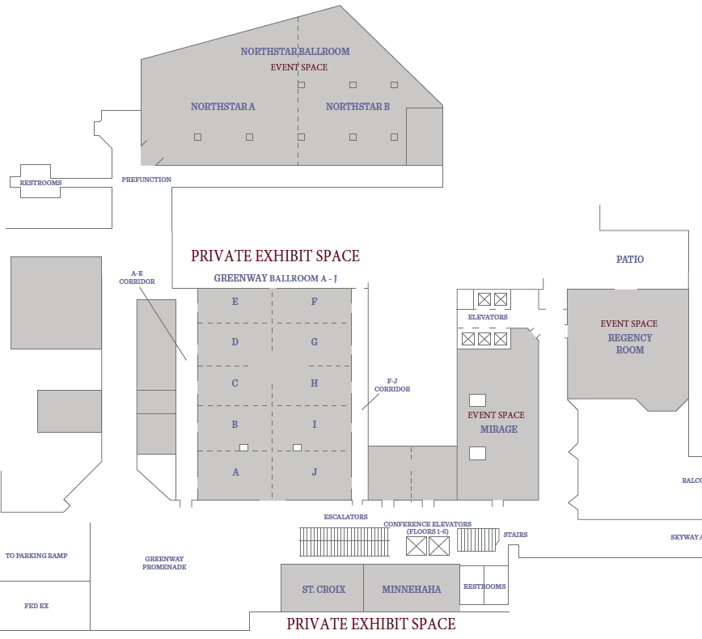

Private rooms have to be paid in full at time of contract, without exception.

ROOM | SIZE | TABLES | BADGES | RATE | SELECTION | SINGLE/SHARED
Greenway A | 1,000 Sq. Ft. | 5 | 6 | $4,000.00 |  | SOLD
Greenway J | 1,000 Sq. Ft. | 5 | 6 | $4,000.00 |  | SOLD
Mennehaha | 965 Sq. Ft. | 4 | 5 | $3,750.00 |  | SOLD
Greenway B | 840 Sq. Ft. | 4 | 4 | $3,500.00 |  | SOLD
Greenway C | 840 Sq. Ft. | 4 | 4 | $3,500.00 |  | SOLD
Greenway D | 840 Sq. Ft. | 4 | 4 | $3,500.00
Greenway E | 840 Sq. Ft. | 4 | 4 | $3,500.00 |  | SOLD
Greenway F | 840 Sq. Ft. | 4 | 4 | $3,500.00
Greenway G | 840 Sq. Ft. | 4 | 4 | $3,500.00
Greenway H | 840 Sq. Ft. | 4 | 4 | $3,500.00 |  | SOLD
Greenway I | 840 Sq. Ft. | 4 | 4 | $3,500.00
St. Croix | 726 Sq. Ft. | 3 | 3 | $3,000.00 |  | SOLD

For Shared Private, provide name(s) of other companies:

For Shared Private, provide amount each company will pay:
(Each company will be required to complete their own contract and provide payment form for their share)

Additional tables will be available for $75 each, and additional exhibitor badge will be available for $150 per person. Please remember that this option is available for staﬀ working your exhibit only.

SHARED EXHIBITS BALLROOMS
MAIN LEVEL EXHIBIT DISPLAY & FEE INFORMATION

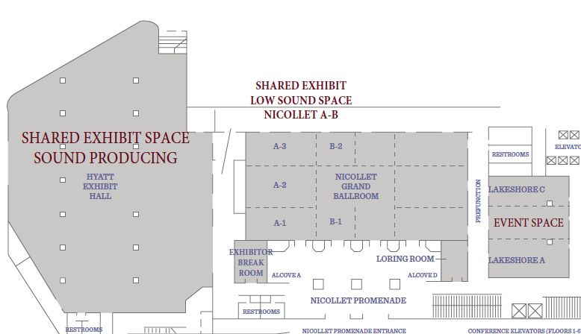

Hyatt Exhibit Hall & Nicollet Grand Ballroom

ROOM | TYPE | SELECTION  (Please Select One) | # OF TABLES
Hyatt Exhibit Hall | Sound Producing
Nicollet Grand Ballroom | Low Sound Producing

Each company wanting to exhibit in the Hyatt Exhibit Hall or in the Nicollet Grand Ballroom at the International Trumpet Guild will be required to purchase at least one table (First table rate: $400).
- Table sizes are 72" x 30"
- 1st Exhibit Table: $400 (Includes 2 full Exhibitor Badge)
- A. Additional Table(s): $295 (Includes 1 full Exhibitor Badge per additional table)
- B. Additional Table(s): $225 (Don’t include Exhibitor Badge)
- Note: If you select option B and later choose to add badges, these will be available at the regular $175 rate per badge.
Add ons available for extra fees:
- Outlets
- Wi-Fi
- Pipe & Drape
Break-down of fees will be provided upon request. Payment for these will be made through the hotel directly and not ITG.
2023 SPONSOR OPPORTUNITIES

Sponsors are recognized on the conference website, emails, social media, receive special recognition in the conference program and announcements at the conference. Additional benefits are available on the attached document and conference website sponsor link.

SPONSORSHIP TYPE | RATE | SELECTION
President Level | $10,000.00
Diamond Level | $8,000.00
Platinum Level | $6,500.00
Gold Level | $5,000.00
Silver Level | $3,500.00
Bronze Level | $2,750.00
Conference Badges | $2,500.00 | SOLD
Conference T-Shirts | $2,500.00 | SOLD
Conference Tote Bag | $2,000.00 | SOLD
ITG Hat | $2,000.00 | SOLD
Volunteer Reception | $2,000.00

PROGRAM ADS & DIGITAL BANNER

For NON-SPONSORS, 2023 advertising rates are available as follow;

SIZE | RATE | SELECTION
Full Page Color Ad + Web Banner | $600.00
Full Page Color Ad | $500.00
½ Page Color Ad + Web Banner | $450.00
½ Page Color Ad | $250.00
Conference App Banner only | $300.00

CONFERENCE SCHOLARSHIP SPONSOR

Please consider providing the unique opportunity for a student to attend the 2023 ITG Conference in Minneapolis by providing one or more $250 student scholarships. Students are chosen by audition and in addition receive a complimentary conference registration.

Donors will be listed in the conference program and recognized during the awards presentation during
the Festival of Trumpets Concert on Saturday June 3, 2023.

SCHOLARSHIPS
Name of Scholarship
(As it should appear in the program)
Name of Scholarship

Name of Scholarship

Name of Scholarship

Name of Scholarship

Total Number of Scholarship(s)

PURCHASE SUMMARY

Please add up all your selections on the form below and select the type of payment arrangement you would like to use. Incomplete contracts will result in delay in booking space.

SELECTION | RATE
Private Exhibit Space
($3,500, or $3,000)
Private Exhibit Space Extra Table
($75 each)
Private Exhibit Space Extra Badge
($150 each)
Private Exhibit Space Extra Table in Shared
($200 each without additional registrations)
Shared Space 1st Table
($400)
Shared Space Additional Tables w badges
($295 each)
Shared Space: Additional Tables without badges
($225 each)
Shared Space: Additional Badges
($175 each)
Sponsorship
$10,000, $8,000, $6,500, $5,000, $3,500, $2,750, or $2,000
Scholarship(s)
($250 each)
Ads (if not included with sponsorship choice)
($600, $500, $450 $300, or $250)
TOTAL

CONTRACT TERMS
A Non-refundable 50% deposit due with the contract in order to hold your space and/or sponsorship.
Full payment to be received no later than March 1st, 2023.
Private rooms need to be paid in full regardless of payment plan option.

Initial Payment | Payment Plan | Payment Plan | Selection
Full Payment (100% | N/A | N/A
Down-Payment (50%) | Balance (50%) 3/1/23 | N/A
Down-Payment (50%) | Payment (25%) 12/1/22 | Payment (25%) 3/1/23

Refund policy
50% of contract amount is non-refundable. No refunds on remaining balance for cancellations after March 15th.

If you are using our payment plan, late payments will be assessed a 10% late fee. Please select best plan which will ﬁt your company the best. and initial next to it.
PAYMENT INFORMATION
All pricing is in U.S. Dollars and payment must be received in such currency.

Payment Method: (Select One)
Type | Selection | Type | Selection
Visa |  | Discover
MasterCard |  | Paypal
American Express |  | Check
Bank Transfer

Credit Card Information
Card Holder Name
Credit Card Number
Expiration Date
CVN Number

We, the undersigned make the application to exhibit at the 47th ITG Conference to be held at the Hyatt Regency Minneapolis, MN from May 30 through June 3, 2023. We understand that in signing this contract we agree to adhere to all of the ITG Conference and Hyatt Regency rules and guidelines.

By signing below, I authorize the International Trumpet Guild Treasurer to charge any
remaining balances according to payment plan.

Signature:

Date:

Mail Checks drawn on only a US Bank or Branch to:
International Trumpet Guild
T.J. Tesh - Treasurer
PO Box 16207,
Hattiesburg, MS 39404
Tel: +1 (563) 676-2435 & Fax: +1 (413) 403-8899
Email: treasurer@trumpetguild.org

PayPal or Bank Transfer:
Please contact ITG Treasurer, treasurer@trumpetguild.org

